**COMPUTER VISION**

Surya Suresh

NSTI W TRIVANDRUM

**1. Image Resizing, Cropping, and Rotation**

**# Load the necessary library**

import cv2

import matplotlib.pyplot as plt

**# Load an image**

image = cv2.imread('3.jpg')

**# Convert the image from BGR (OpenCV format) to RGB (Matplotlib format)**

image_rgb = cv2.cvtColor(image, cv2.COLOR_BGR2RGB)

**# Resize image to 256x256 pixels**

resized_image = cv2.resize(image_rgb, (125, 128))

**# Display the original and resized images**

plt.figure(figsize=(10, 5))

plt.subplot(1, 2, 1)

plt.title('Original Image')

plt.imshow(image_rgb)

plt.axis('off')

plt.subplot(1, 2, 2)

plt.title('Resized Image (125x128)')

plt.imshow(resized_image)

plt.axis('off')

plt.show()

**# Save or display the resized image**

# cv2.imwrite('resized_image.jpg', resized_image)

**# Crop image to a region (x, y, width, height)**

cropped_image = image_rgb[50:130, 50:200]

**# Display the original and resized images**

plt.figure(figsize=(10, 5))

plt.subplot(1, 2, 1)

plt.title('Original Image')

plt.imshow(image_rgb)

plt.axis('off')

plt.subplot(1, 2, 2)

plt.title('cropped_image')

plt.imshow(cropped_image)

plt.axis('off')

plt.show()

**# Rotate image by 45 degrees**

(h, w) = image_rgb.shape[:2]

center = (w // 2, h // 2)

M = cv2.getRotationMatrix2D(center, 45, 1.0)

rotated_image = cv2.warpAffine(image_rgb, M, (w, h))

**# Display the original and resized images**

plt.figure(figsize=(10, 5))

plt.subplot(1, 2, 1)

plt.title('Original Image')

plt.imshow(image_rgb)

plt.axis('off')

plt.subplot(1, 2, 2)

plt.title('rotated_image')

plt.imshow(rotated_image)

plt.axis('off')

plt.show()

**OUTPUT:-**

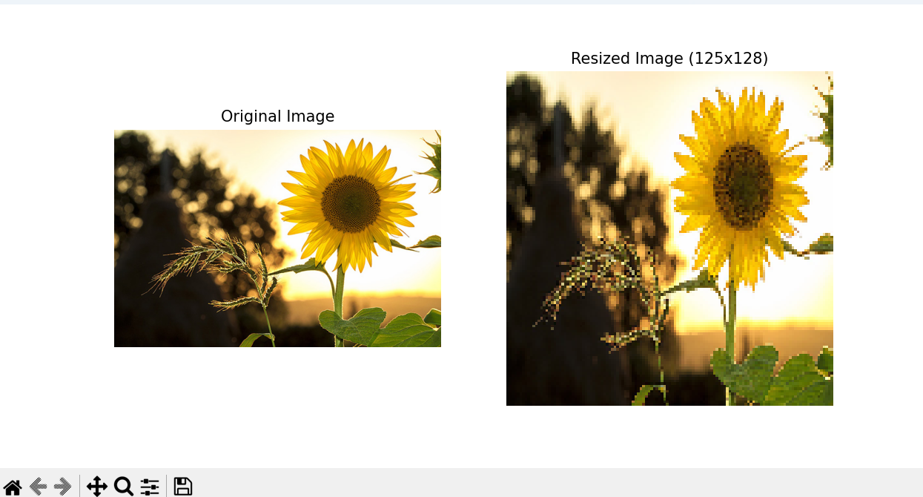

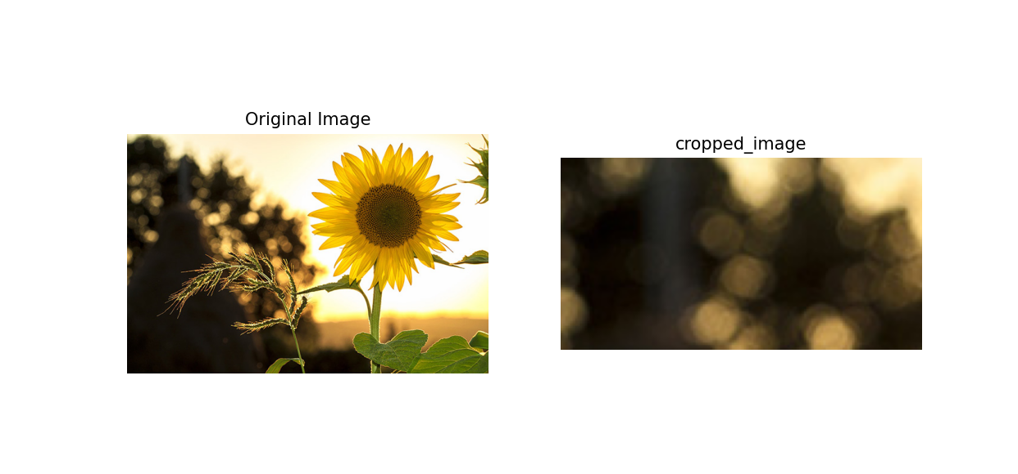

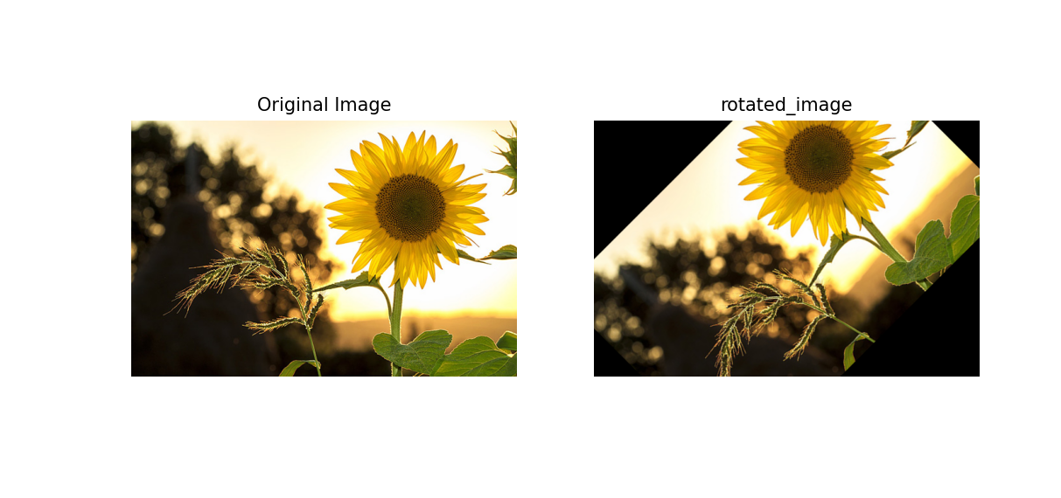

**2. Loading_Image_Formats_Tutorial**

import cv2

import matplotlib.pyplot as plt

**# Load an image using OpenCV**

image_path = "3.jpg"

image_cv2 = cv2.imread(image_path)

**# Convert the image from BGR to RGB**

image_cv2_rgb = cv2.cvtColor(image_cv2, cv2.COLOR_BGR2RGB)

**# Display the image**

plt.imshow(image_cv2)

plt.title('Image loaded with OpenCV')

plt.show()

from PIL import Image

**# Load an image using PIL**

image_pil = Image.open(image_path)

**# Display the image**

plt.imshow(image_pil)

plt.title('Image loaded with PIL')

plt.show()

import imageio

**# Load an image using imageio**

image_imageio = imageio.imread(image_path)

**# Display the image**

plt.imshow(image_imageio)

plt.title('Image loaded with imageio')

plt.show()

**# PNG image path**

image_path_png = "4.png"

image_path_jpg = "2.jpg"

**# OpenCV**

image_cv2_png = cv2.imread(image_path_png)

image_cv2_png_rgb = cv2.cvtColor(image_cv2_png, cv2.COLOR_BGR2RGB)

plt.imshow(image_cv2_png_rgb)

plt.title('PNG loaded with OpenCV')

plt.show()

**# PIL**

image_pil_png = Image.open(image_path_png)

plt.imshow(image_cv2_png_rgb)

plt.title('PNG loaded with OpenCV')

plt.show()

**# imageio**

image_imageio_png = imageio.imread(image_path_png)

plt.imshow(image_cv2_png_rgb)

plt.title('PNG loaded with OpenCV')

plt.show()

**OUTPUT:-**

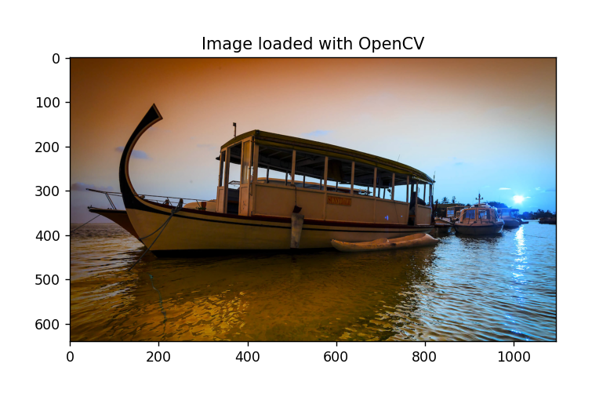

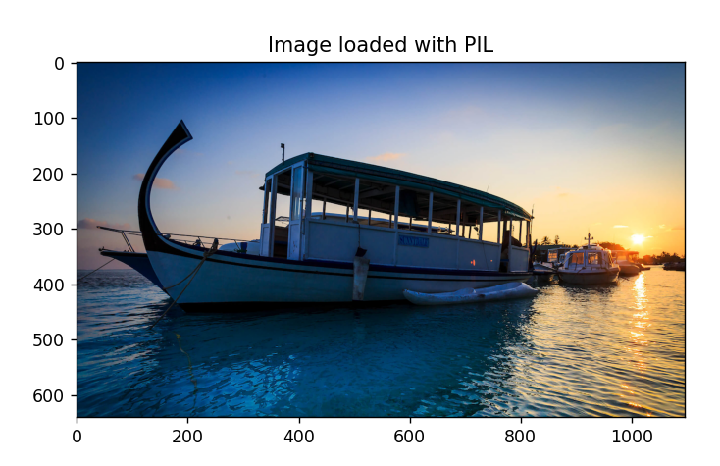

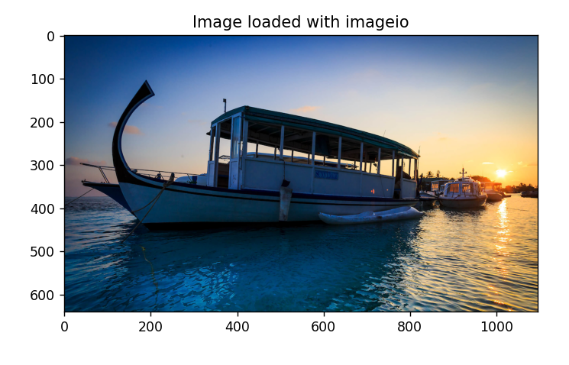

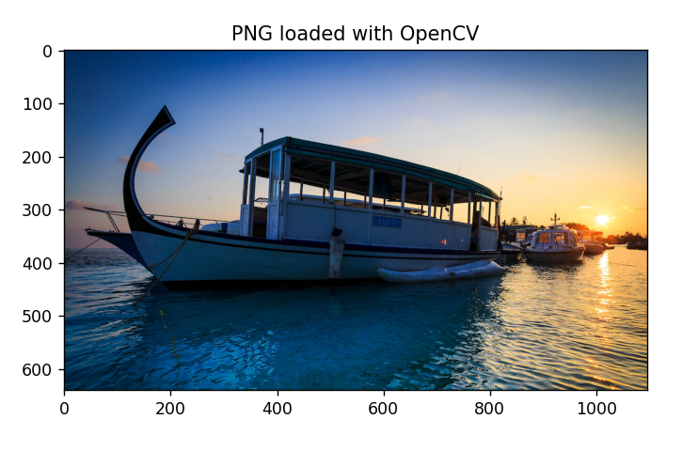



**3. Image Denoising**

**# import necessary libraries**

import cv2

import matplotlib.pyplot as plt

**# Load an image**

image = cv2.imread('1.jpg')

**# Convert the image from BGR (OpenCV format) to RGB (Matplotlib format)**

image_rgb = cv2.cvtColor(image, cv2.COLOR_BGR2RGB)

**# Apply Gaussian blur to denoise**

denoised_image = cv2.GaussianBlur(image_rgb, (11, 11), 0)

**# Display the original and resized images**

plt.figure(figsize=(10, 5))

plt.subplot(1, 2, 1)

plt.title('Original Image')

plt.imshow(image_rgb)

plt.axis('off')

plt.subplot(1, 2, 2)

plt.title('denoised_image')

plt.imshow(denoised_image)

plt.axis('off')

plt.show()

**# Convert to grayscale**

gray_image = cv2.cvtColor(image_rgb, cv2.COLOR_BGR2GRAY)

**# Apply histogram equalization**

equalized_image = cv2.equalizeHist(gray_image)

**# Display the original and resized images**

plt.figure(figsize=(10, 5))

plt.subplot(1, 2, 1)

plt.title('Gray Image')

plt.imshow(gray_image, cmap="gray")

plt.axis('off')

plt.subplot(1, 2, 2)

plt.title('equalized_image')

plt.imshow(equalized_image, cmap="gray")

plt.axis('off')

plt.show()

**OUTPUT:-**

